Tanmay Fadnavis

SUID: 971141760

Computer Security

Lab-3

# TASK 1: EXPLOTING THE VULNERABILITY

The screen shots for task 1 are below.

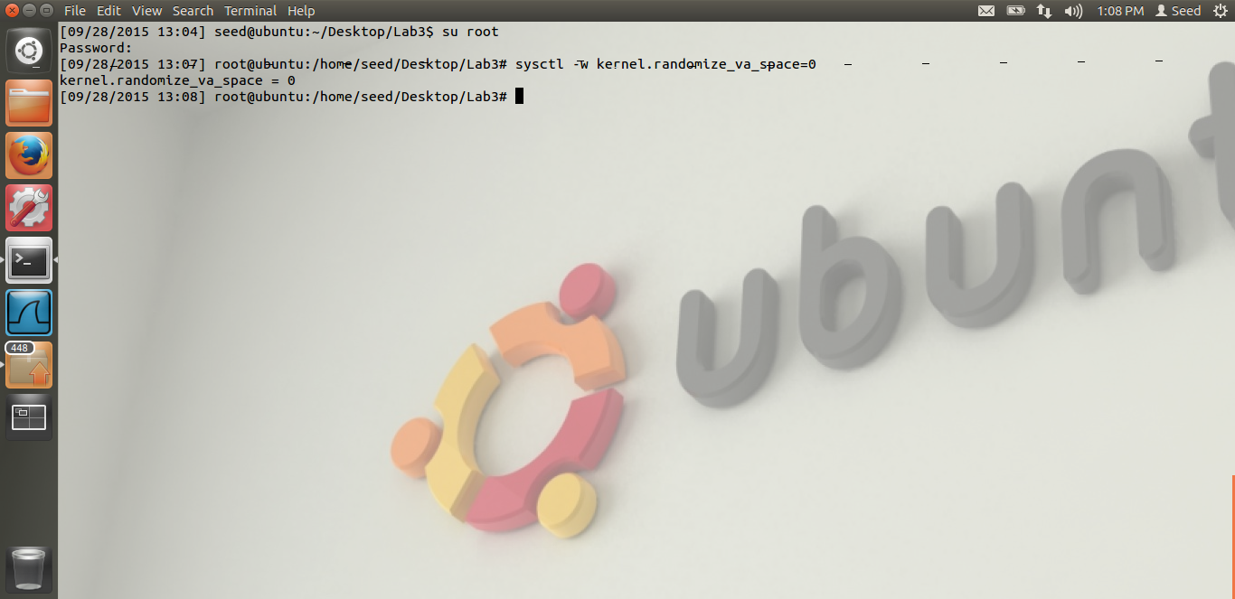

Here we can see, we have turned off the address randomization. We are doing the initial set-up.

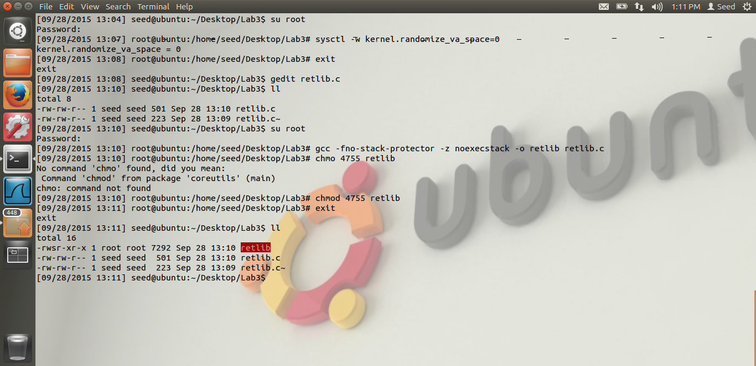

I compile the vulnerable program provided by Dr. Du, retlib.c As you can see from the screen shot, I have compile it and kept the stack as non-executable. I have turned off the stack guar protector. And made it a set-UI program. The red color indicates that. Thus, our initial set-up is complete.

To get the address of system and exit.

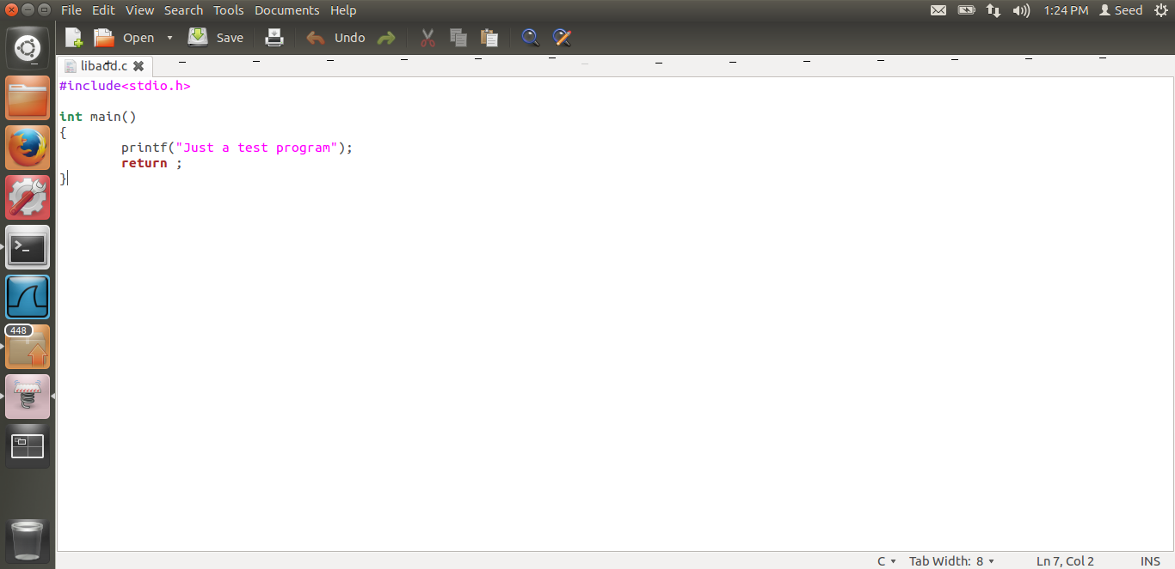

Libadd.c is the test program which I have return to get the address of system and exit function calls.

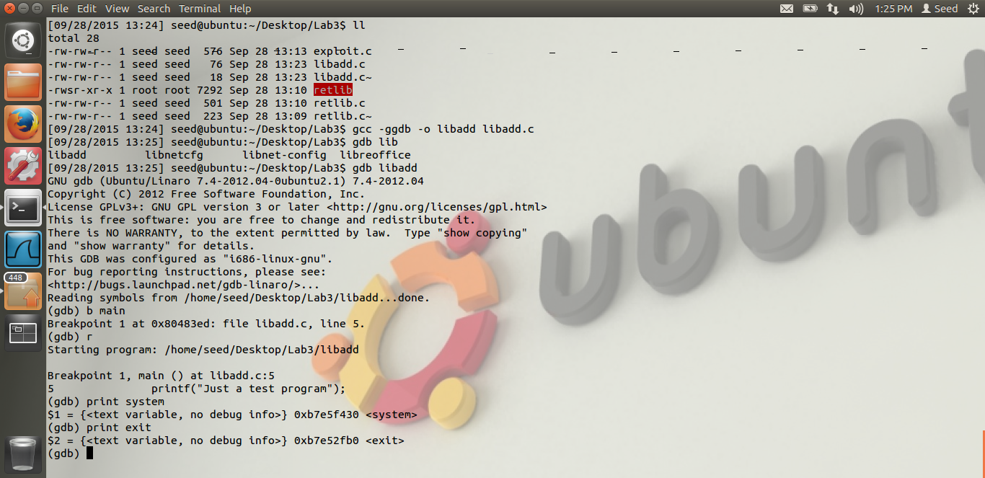

When we compile the above program using gdb, as seen from the screen shot, we run it using the gdb. From the screen shot, we can see that when we type the “print system” an “print exit” command, we get the address of those system calls. As the randomization is off, these addresses will be the same. The address which we get are, for the system, “0XB7E5F430” and for the exit “0XB7E52FB0”. After this, we need to create our environment variable MYSHELL to put the string /bin/shell an get the address for the same.

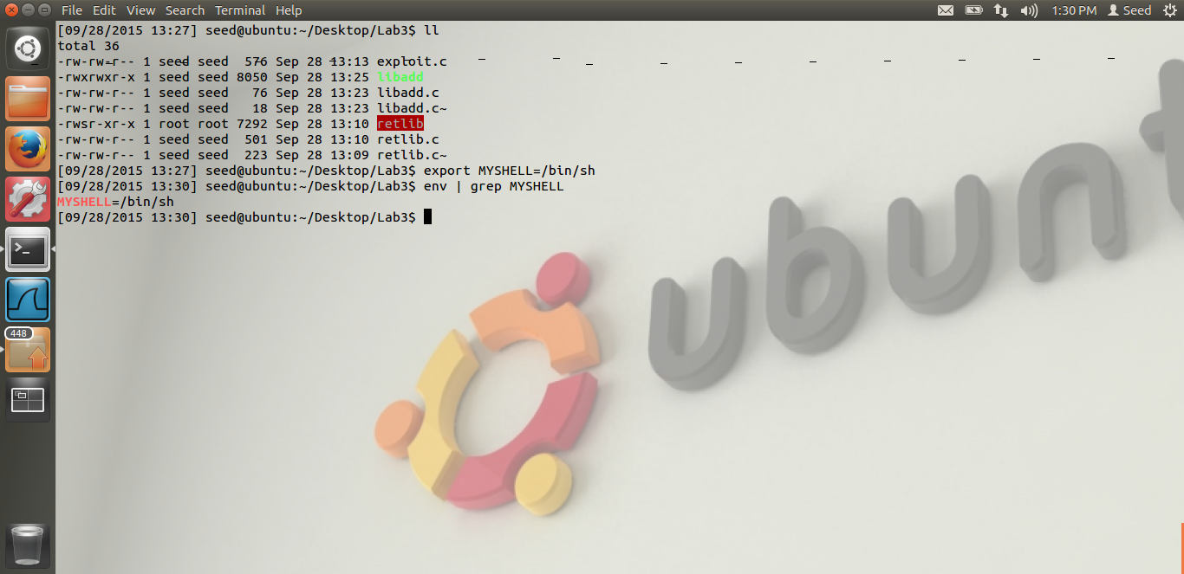

We have exported our variable MYSHELL as seen from the screen shot.

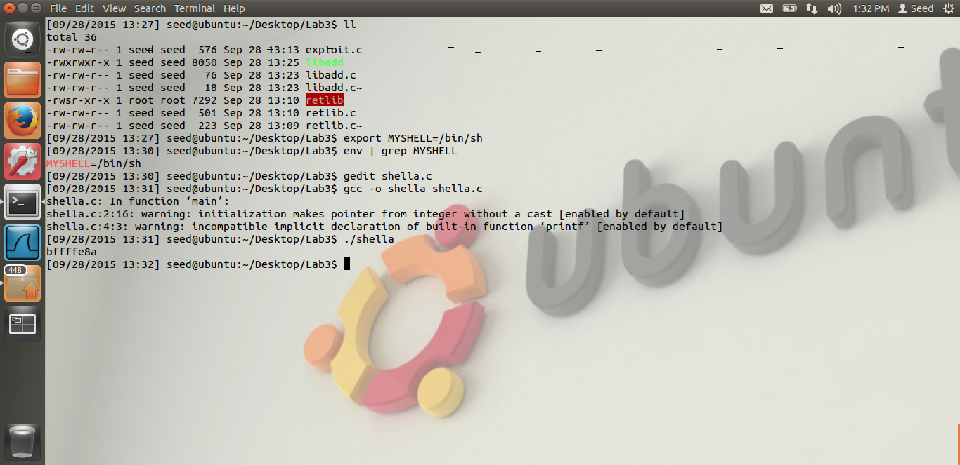

Then we run the program given by Dr. Du. The program is stored in shella.c From the screen shot, we can see that, when we compile an run the program, we get the address of our environment variable MYSHELL. The address is “0XBFFFFE8A”. Thus now, we have all the three addresses. What we now require are the values of X,Y,Z in the exploit.c program, given by Dr. Du. Below I describe how those are found.

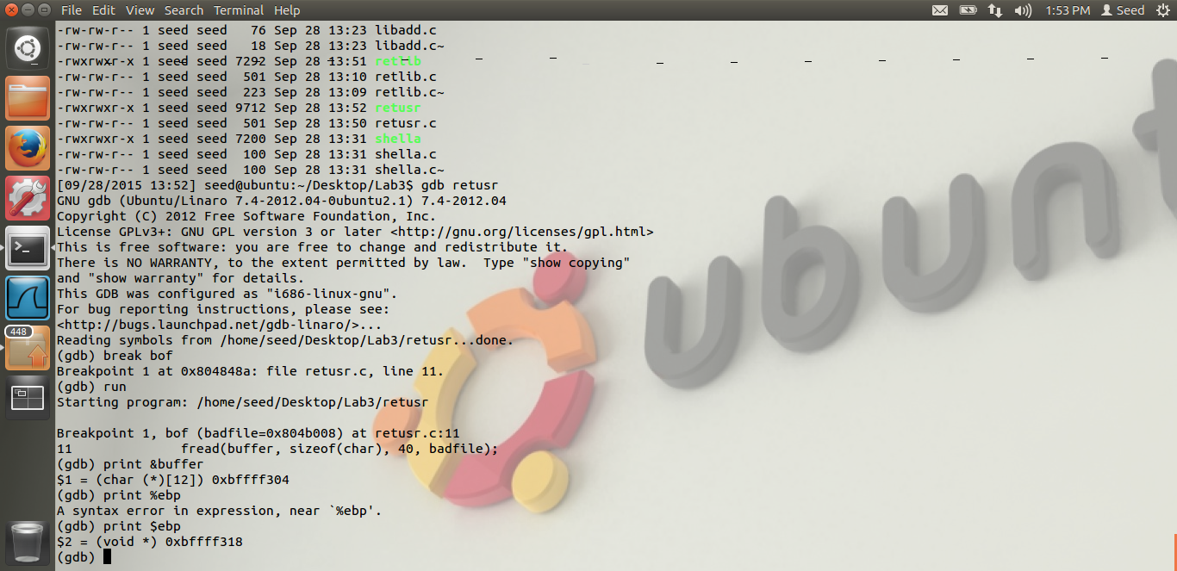

Now, what I have done is, I have made a user program called retusr.c which is basically the copy of the set-UID program. The reason is, I want to know the number of bytes between the buffer start address and the ebp. From the screen shot, we see that buffer starts at address 0XBFFFF304 and ebp is pointing to address 0XBFFFF318. So 14 in hexadecimal is 20 in decimal i.e. basically, 20 bytes we have got for the buffer, this is the buffer of the function bof. Our buffer is of 12 bytes, but we are getting 20 bytes. Now from the stack, I will show how I get the values of X,Y,Z i.e. we will calculate where to put the values of system(), exit() and MYSHELL with respect to this buffer.

The stack layout for the function main and bof is as below. We will calculate where to put the address from this.

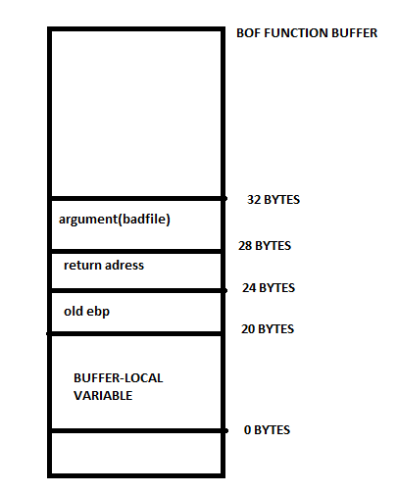

From the above, we see the buffer frame, of the BOF function. We can see that, buffer is taking 20 bytes, then plus 4 bytes are storing old ebp, then plus 4 bytes are storing return address, then plus 4 bytes are storing argument. After the function call, the function will jump to the address stores at return address. And we want to execute system function, hence we will store the system function address at this location. As this location is 24 bytes from the start of the buffer, we will store it at *(long *) &buf[24],(Y value) the address of the system call. Remember, our buffer is of the length 40, hence we are over-flowing all these addresses, Thus, we get the location with respect to the start of the buffer, where we should store the address of the system() function call, i.e. 24.

Now we need to find where to store the argument for the system function call, and the exit() system call address. Now let us see the stack after the BOF function.

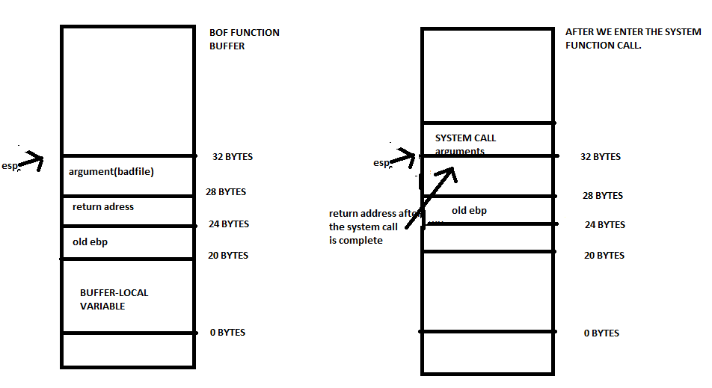

Now, as we know, once we get out of the function, the stack will restore itself to the original position. Then, first we put the return address, of where we need to return, once the function is over. This return address is the exit function return address, because we need to exit the program once we are out of the root shell. Thus, now the esp will point to 32 bytes with respect to the start of the buffer, Thus, we need to put the return address at 28 bytes, i.e. we first put the return address, where we need to go after the function is complete. Hence, with respect to the buffer, it is 28(Z value) bytes offset, this is where we will put the exit() function call return address. Now old ebp will be put, hence old ebp will be put to 24 bytes. Now ebp will point to 24 bytes. As we know, the arguments are places at ebp + 8, hence we will put the system call arguments, in our case the address of MYSHELL to 24 + 8, i.e. 32(X value) bytes with respect to the buffer. Thus, we now have all the 3 locations, all the 3 addresses, and know we can do the attack, return-libc attack. Thus the system() value Y is 24, /bin/shell, MYSHELL value, X is 32, exit() value, Z is 28.

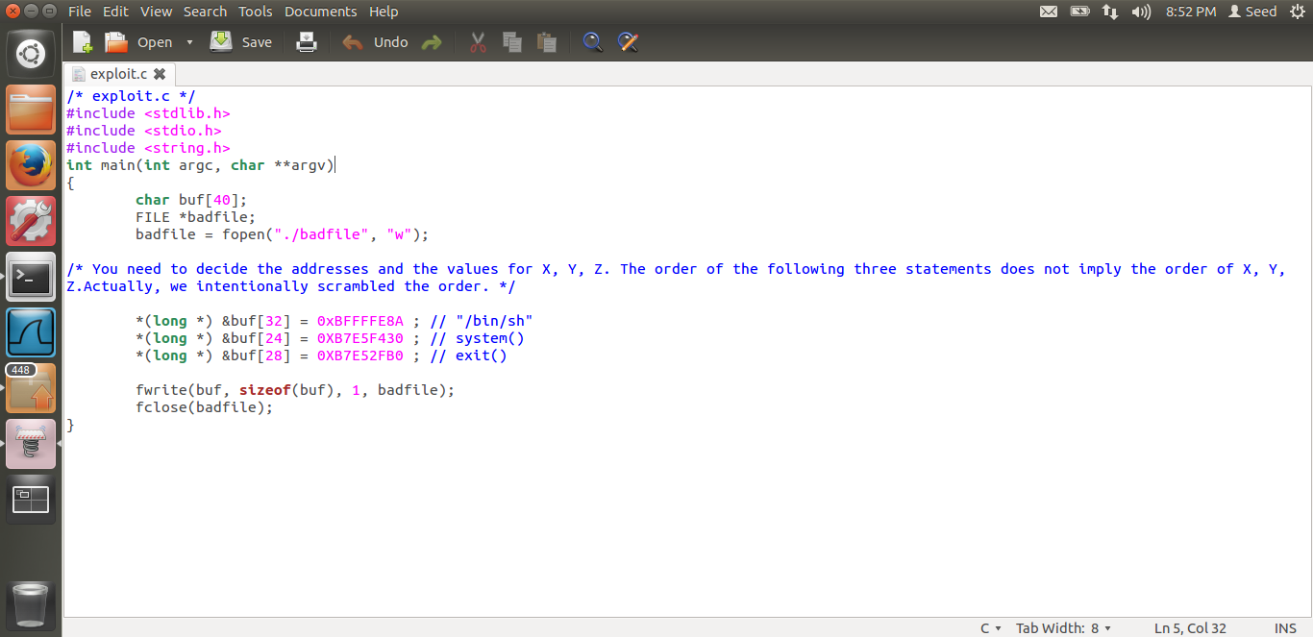

From the screen shot, we can see my exploit program, i.e. the address of the system(), exit() an my shell and the values of X,Y,Z as explained above.

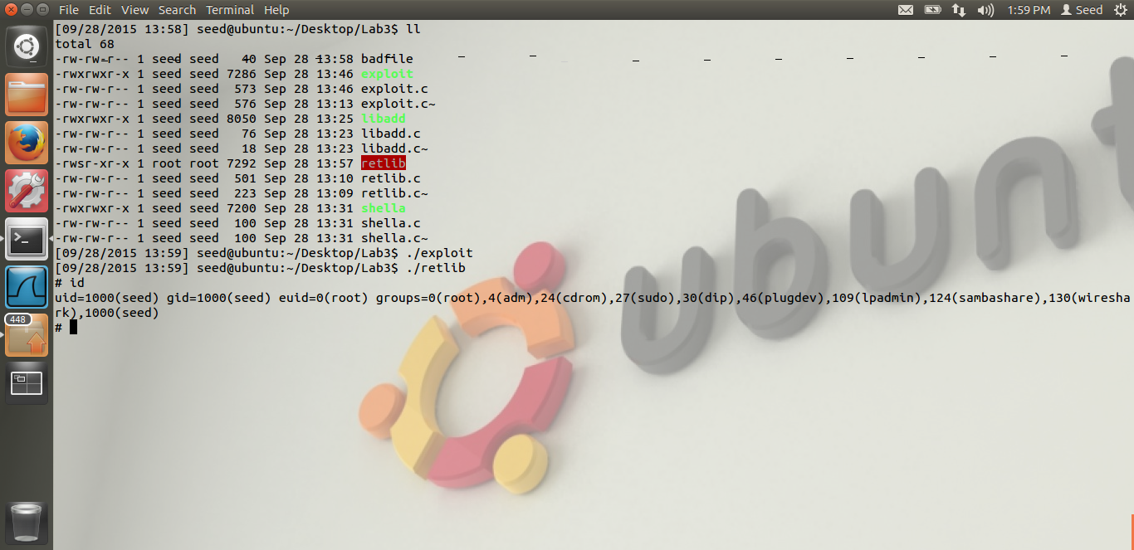

Now, when we compile the exploit.c and run the retlib, we get the root shell as seen from the screen shot. Hence our attack is successful. Thus, we have successfully implemented the return-libc attack.

Thus, I have explained how we get the values of X,Y,Z and all the three return addresses.

Now, we will change the name of the retlib file to newretlib and check if we are able to repeat the attack successfully.

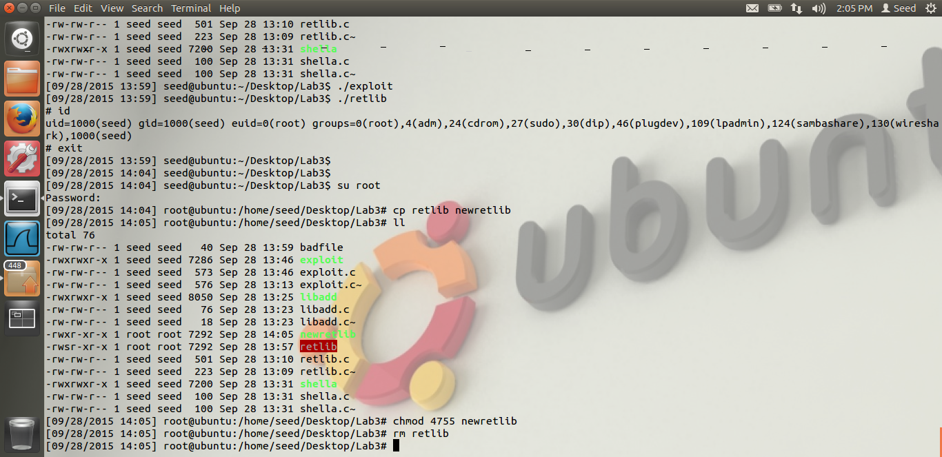

Above, we can see, I have changed the name of the old retlib file, and changed it to newretlib. I have made it a set-UID program as before and everything is the same. Let us execute this.

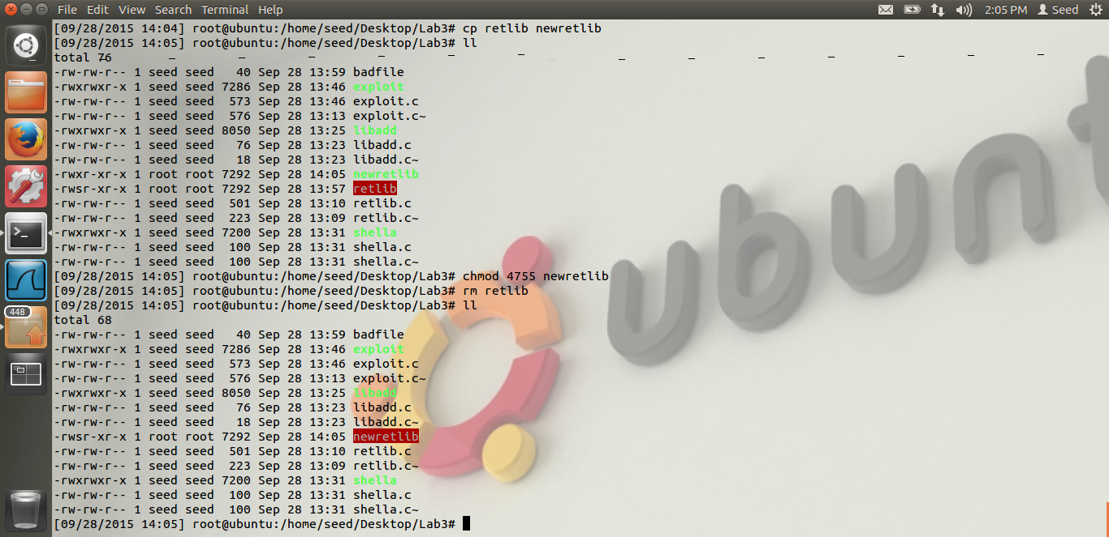

Again, the newretlib is the new program.

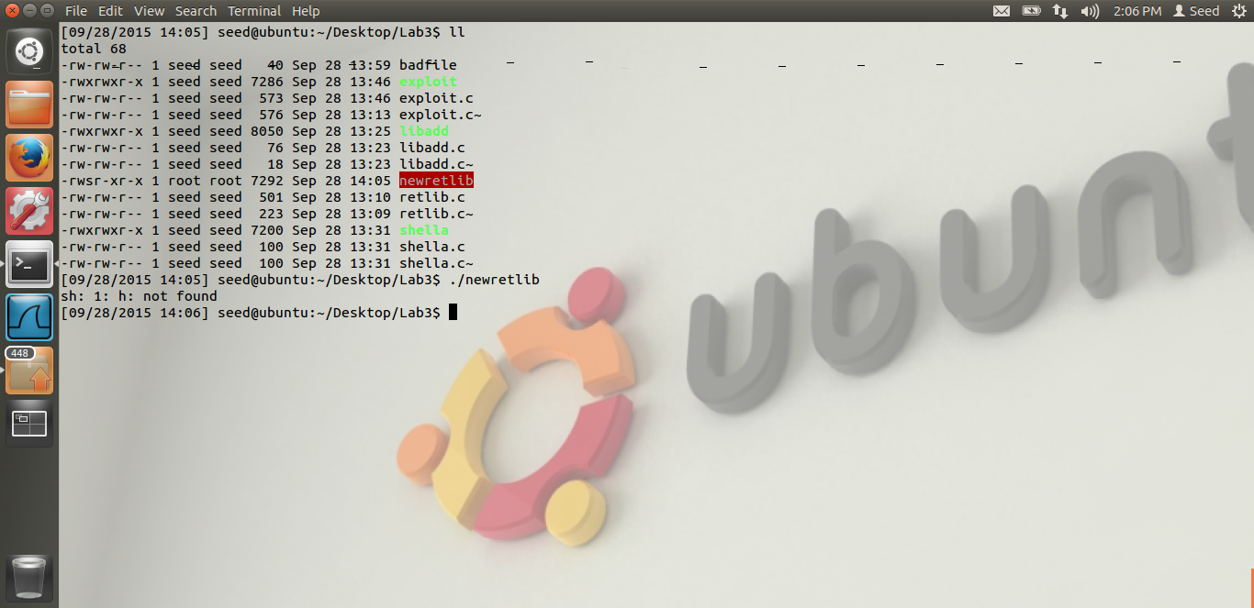

When we execute this new program, we get the error as seen from the screen shot, “h not found”.

Reason: The reason is simple. When we change the filename, the addresses of the environment variables are also changed by some small amount. Because, even the file names are somehow stored at the same place on stack as the environment variables. Thus, due to change in file name, the address of our MYSHELL variable has changed. Hence, our code is able to take only “h” at that address. As this is the argument to the system call, it is not able to recognize this and hence it gives the error. Thus, we are not able to attack successfully. Hence due to file name change, our attack was not successful and we have proved it.

# TASK 2: ADDRESS RANDOMIZATION

The screen shots for Task2 are below.

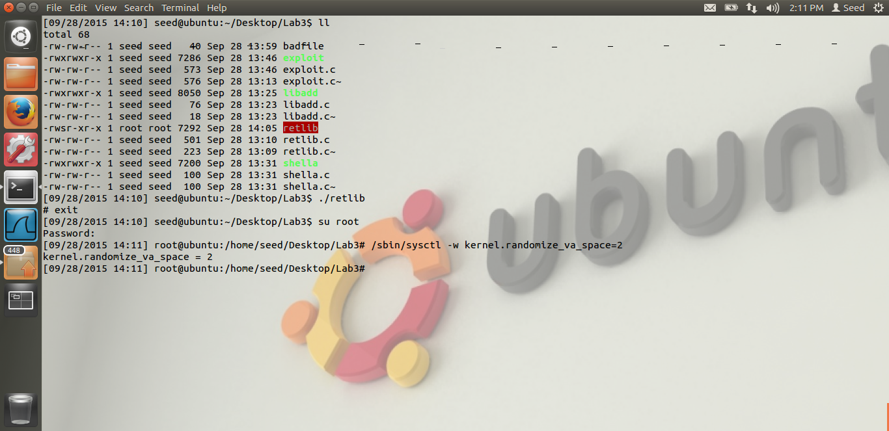

As we can see from the above screen shot, we have turned on the address randomization.

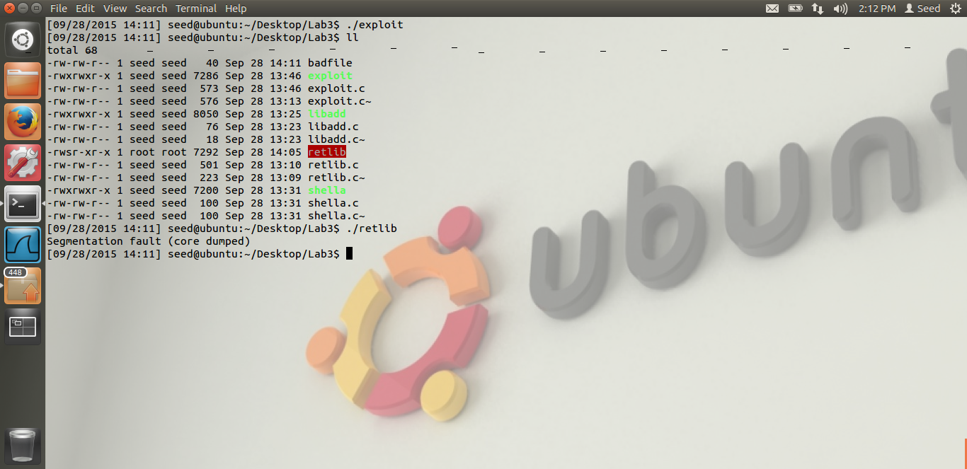

We repeat the Task1 again. As seen from the screen shot, we get the segmentation fault. Hence, we are not able to do the attack successfully.

Reason: When we turn on the address randomization, the stack could be allocated at any random address. This is unlike our first task, where the addresses for all the 3 parameters, i.e. the system() function call, the exit() function call and the MYSHELL variable is fixed. Now, as the address is randomized, these addresses can be anything, they are random. Thus, only when all the 3 address match the address we have provided in our code, the attack will be successful. This probability is highly highly unlikely. Hence, we are not able to do the attack successfully.

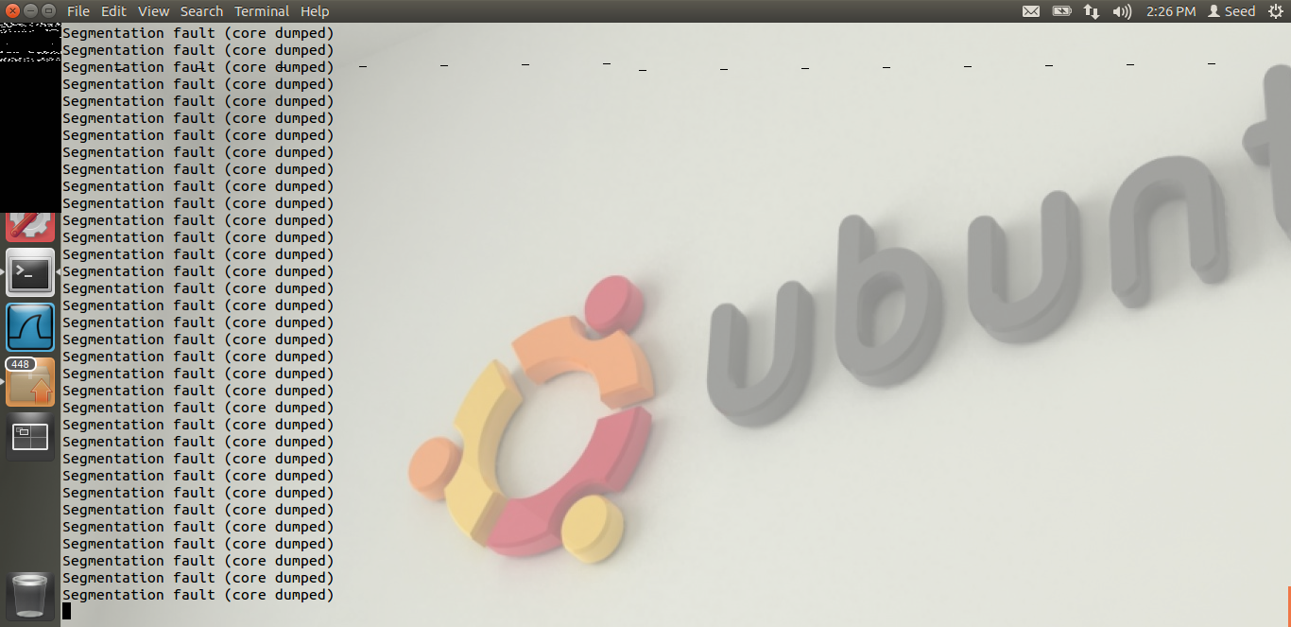

We can see, even though we put the code, in a while loop, we are not able to do the attack. Thus, because of address randomization, even if we run our code in a while loop, the possibility of all the 3 address becoming the same as the address we have provided at the same time is highly unlikely. Hence, because of this, we are not able to do the attack successfully.

# TASK 3: STACK GUARD RANOMIZATION

The screen shot for task 3 are below.

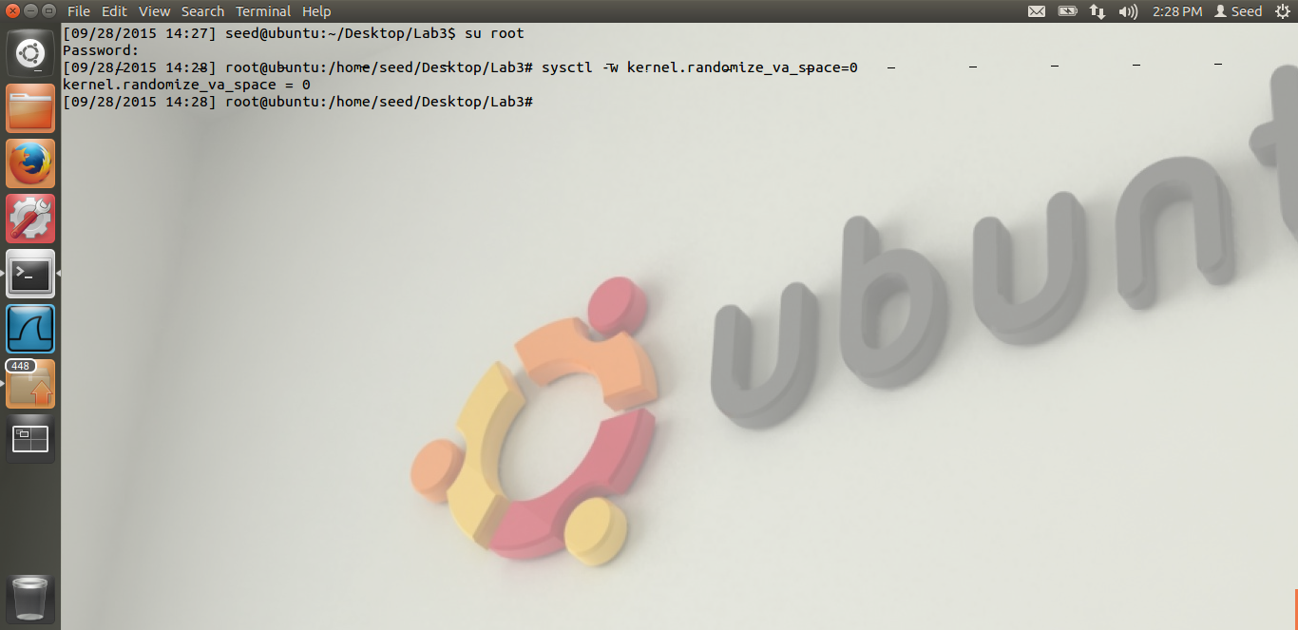

We can see from the screen shot, we have turned off the address randomization.

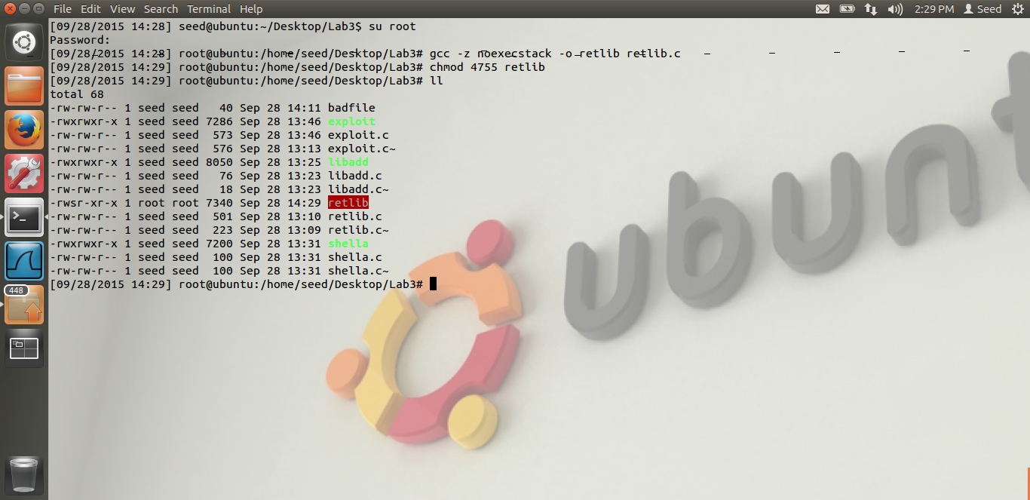

From the screen shot, we can see that, we have compiled our malicious code but the stack guard protection is on. So, the stack is non executable, but the stack guard is on. Now, let us do the attack and lets see what happens.

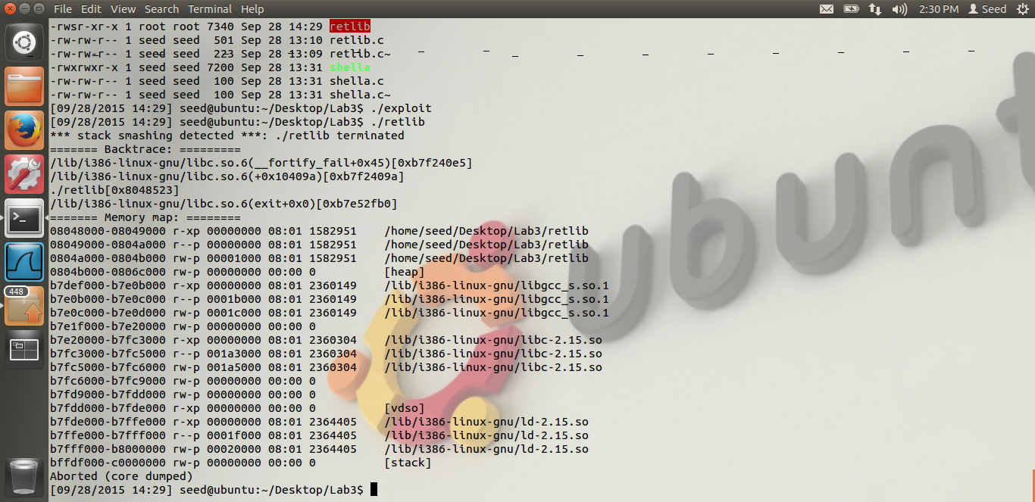

From the above screen shot, we can see that, when we repeat our task-1, we get the above error.

Stack smashing detected. Thus, as we can see, we are not able to attack successfully, even though address randomization is off.

Reason. The GCC, i.e. the compiler protects the stack using the stack guard protection. The stack guard protections works as follows. We(The compiler) puts a local variable in the stack, before the return address, i.e. we can put a local variable, below where the ebp is pointing. We put a random number in this variable. Thus, whenever there is a buffer overflow, we cannot overflow the return address without overflowing the local variable value. Because it is before the return address, i.e. it is stored before the return address. And we store this value in the heap. We cannot store it in stack, as stack can be overflowed. Before we return, the compiler checks this local variable value with the value stored in the heap. If it is different, then the compiler can come to know that there has been a buffer overflow attack. Thus, it will detect the stack smashing, which it shows in the output, as seen from above screen shot. If both the value are equal, that means, there has been no attack.

Thus, in the above way, the compiler executes the stack guard protection.